Pekonya Trinity Encounters
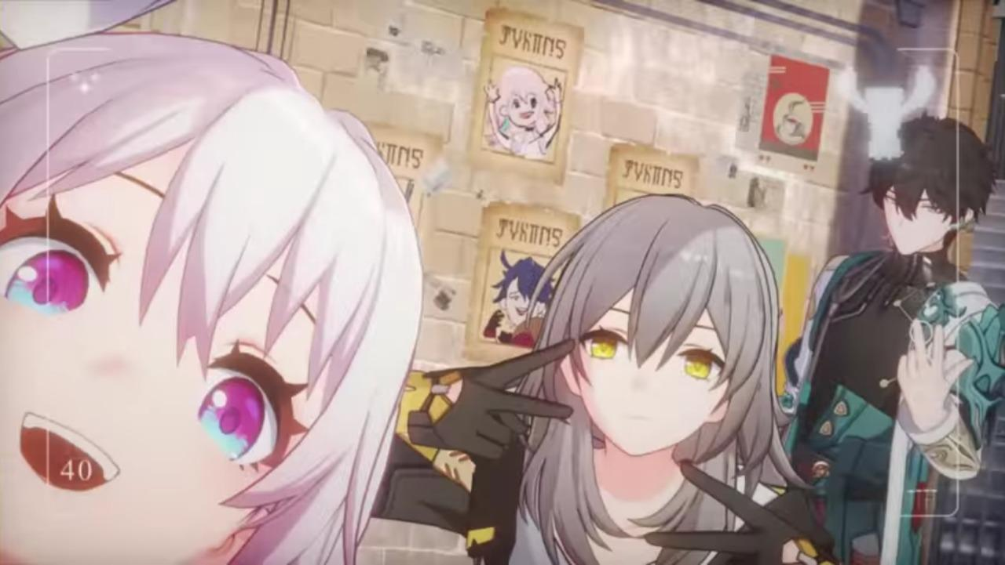

First informations
6 digit tourney
- 2v2 (teams of 3)
[100k - 200k , on screening period]
>>> must not have 92k peak rank on profile

Channel lists

a.) Conquest-Guide
(important/essential information ton top)
=welcome
the-guarded-entrance-door
=announcements
important tourney announcements
= bootleg-announcements
any staff member’s ‘important’ announcement
= links-faq
important tourney links & frequently asked questions (FAQs)
=match-results
channel name speaks for itself
= get-to-know-teams

b.) Conquest-Journey
= genenya
uwuelcome
= questions-suggestions
don't hesitate to tell your inquiries & thoughts on improving our tournament experience here
= qualifiers-scheduling-rescheduling
follow the format @ pins <> pick a qualifiers lobby & write it down here
= match-rescheduling
follow the format @ pins <> reschedule your matches here + proof of agreement
= pool-feedback
please provide the most constructive feedback as possible, remain civil conversations
# Call center

c.) Staff-Wide-Nya
(Staff wide)
= nyanners
cuties
= admins
golf
= gfx-sheets
idk if I'm even recruiting one
= poolers
hiii osuhow to pool
= feedback-poolers
the-judge
= streamentate
place for the streamer & commentator duo communications
=streamer
exclusive for streamers channel for confidential stuffs
= referees
ty for ref
# Staff-VC
# Stream-VC
# Stream-VC2

Roles (adding roles, I’ll just do this manually for now)
- Host #4693DC
- Admins #749df0
- GFX #b55fd4
- Sheeter #3D2A83
- Pooler#CF3273
- Pool Feedback Team #EA8FA1
- Streamer #c09523
- Commentator #dcd281
- Referee #2A8335
- Staff #D2D628

- Outstanding Triumvirate (finalists) #4BCF5F
- Qualified Triumvirate (top 32) #E76132
- Challenger Triumvirate (registered) #DB3629
- Observer (spectators/eliminated) #595D59

Reference used for the parts for now : BOP2
https://osu.ppy.sh/community/forums/topics/1422022?n=1

Logos/Banners
- Main tournament banner
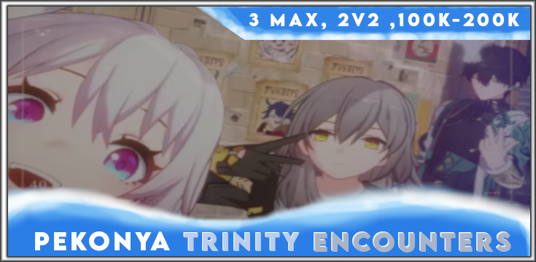
- Server Logo (discord)
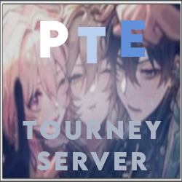
- Information

- Qualifiers

- Match Rules

- Schedule


- Prizes

- Staff Team


Others possible banners in the future
- Player banners (top 1-4)
- Staff banners (contribution)

BB code for staff applications (filled all i think as i remembered)
[ Staff Applications Only || STD 2v2 To3 || 100k - 200k ] Pekonya Trinity Encounters
[centre]
[img]https://cdn.discordapp.com/attachments/1122141302985871482/1122435692383973456/Pekonya_Trinity_Encounters_Logo3.png[/img]

[notice][color=#aab4c5]Hellonya to everyone ![/color]

I, Pekonya, is looking for staff open-heartedly to the first iteration of [color=#8fa3cc]Pekonya Trinity Encounters .[/color]
(PTE for short). [/notice][/centre]
[centre][img]https://cdn.discordapp.com/attachments/1122141302985871482/1122445876569313331/Pekonya_Trinity_Encounters_Information.png[/img][/centre]
[notice][centre][url=https://osu.ppy.sh/users/17959882]Non-existant staff registration forms[/url] || [url=https://osu.ppy.sh/users/17959882]Not yet revealed Discord Server[/url][/centre]
[/notice]
[notice]Most of the information about the tournament format is mostly mentioned in the title header.

[size=150][b] Schedule : [/b] Not yet fully planned as of now. [/size]

[b]Team composition :[/b] 3 members max, 2 players are going to play each map.
[b] Rank range :[/b] 100,000 - 200,000 on the screening stage
[b] Peak Rank Limit :[/b] Highest rank must not be more than 90,000.[/notice]
[notice]Roles such as [color=#cf3273]Poolers (including the feedback team)[/color], [color=#c09523]Streamers[/color], [color=#dcd281] Commentators [/color], and[color=#2a8335] Referees [/color]are the available options to choose from.

Highly encouraged for [color=#cf3273] poolers [/color] and [color=#c09523] streamers [/color][u]with any previous experiences[/u] (I’m close to little idea on handling polling and streaming stuffs, any sort of help with these are highly appreciated)

Then the rest of the roles such as [color=#2a8335] referees [/color]and [color=#dcd281] commentators [/color], yeaa just lemme knows.
[/notice][centre]
[img]https://cdn.discordapp.com/attachments/1122141302985871482/1122609404471156787/Pekonya_Trinity_Encounters_contacts.png[/img]

[notice]For further inquiries, don’t hesitate to contact me through [color=#4693dc][b]discord (pekonya)[/b][/color] or [color=#ac396d][b]osu! DMs (-PeKoRa-)[/b][/color]

As everyone’s main priority, [size=150]just enjoy and have fun staffing![/size]
[/notice][/centre]
[code]
Thank y’all for your ample time, good day!
Sincerely, -PeKoRa- :)
[/code]

BB code for staff list (soon)
Reference : https://docs.google.com/spreadsheets/d/10ZvWn-gcCN-293mr9jC7-rb6Qd21OaC3eEYwqIAc4EE/edit?usp=drive_link

[b]Host:[/b] [url=https://osu.ppy.sh/users/-PeKoRa-][color=#FFFAAA][b]-PeKoRa-[/b][/color][/url][img]https://osuflags.omkserver.nl/PH-20.png[/img]
[b]Admins:[/b]
[b]Poolers:[/b]
[b]Playtesters:[/b]
[b]Referees:[/b]
[b]Streamers:[/b]
[b]Commentators:[/b]
[b]Graphics:[/b]
[b]Sheets:[/b]

Referee sheets
Qualifiers stage:
https://docs.google.com/spreadsheets/d/1pMXcxIl6sKegGLLZuazjrN3eussP2Sp23xXDc-hlqfg/edit?usp=sharing

Bracket stage : https://docs.google.com/spreadsheets/d/1furEKtJ5gEFQB_8CRy1iNCTi7QIoca2qGHOcFGl5QjU/edit#gid=822251654

Pooling sheet
Poolers and mappool-feedback team :
https://docs.google.com/spreadsheets/d/1WeVYxODFFkAmdP-uHAXnUhNm6E5Mao-pWS0UkDdVoEY/edit?usp=sharing

Admin Sheet
https://docs.google.com/spreadsheets/d/1CljITs3NJUVgxxEJtrtcox1xB5_GTFbV5Vgddvo41kI/edit?usp=drive_link

Main sheet

https://docs.google.com/spreadsheets/d/1u1R-0YeX71qksHP7hWq8QkjcpECX-9LSvskalZ8hxdg/edit?usp=sharing

Google Forms

Staff Registration Forms

Team Registration Forms
https://docs.google.com/forms/d/e/1FAIpQLSdw9sbLKZfFbt1KGH9cU-okXaav3YzfJRZZXA5scRejJmVKMw/viewform?pli=1

FA Registration Forms
https://docs.google.com/forms/d/e/1FAIpQLSd9k6dWZGEULcX8brgyCZkGFTI52YpSpSpe5N9D9E3i8zW2dA/viewform?usp=sf_link

🪄

